The manual of „BluePayment” module for Magento 2

|  |  |
| --- | --- |
| **Project** | **BluePayment system – Magento 2 module** |
| **Authors** | Tobiasz Kosmela, Krzysztof Graman |
| **Title** | The manual of „BluePayment” module for Magento 2 |
| **Type** | User manual |
| **Document version** | 1.5.4 |
| **Extension version** | 2.13.5 |

# Table of conents

Table of conents 2

Basic information 5

List of Features: 5

Requirements 5

Description of changes 5

2.13.5 version 5

2.13.4 version 5

2.13.3 version 5

2.13.2 version 5

2.13.1 version 5

2.13.0 version 5

2.12.0 version 6

2.11.0 version 6

2.10.0 version 6

2.9.0 version 6

2.8.2 version 6

2.8.1 version 6

2.8.0 version 6

2.7.7 version 6

2.7.6 version 6

2.7.5 version 6

2.7.4 version 6

2.7.3 version 7

2.7.2 version 7

2.7.1 version 7

2.7.0 version 7

2.6.0 version 7

2.4.0 version 7

2.3.0 version 7

Installation 7

Module activation 7

Activation via Administration Panel 7

Activation via command line 9

Configuration 10

Basic module configuration 10

Payment gateways 10

Refreshing list of payment gateways 10

Payment gateways editing 10

Collapsible gateway list 12

Refreshing cache 12

Refunds 13

Refund – Credit Memo 13

Refund - manual 13

Payment in iframe 14

Activation 14

BLIK 0 16

Activation 16

Google Pay 17

Activation 17

Automatic payments 18

Activation 18

Card managing 18

Generate orders from admin panel 20

E-mail template 21

Waiting before redirect page 21

Activation 21

Module updating 22

Module uninstallation 22

Through Web Setup Wizard 22

Through command line 24

(optional) Cleaning files and data bases 24

# Basic information

The Blue Media Online Payment Plugin for Magento is the easiest way to allow your online store customers use the most popular payment methods. When integrated with the store, the plugin offers the possibility to add over 400 banks to the payment options.

## List of Features:

* Multiple store service.
* Optional checkout without registration.
* Two implement modes.
* Two ways to view the payment methods in the store:
  + On the Blue Media page – a classic or personalized view.
  + Within the store – an integrated view where the customer is immediately redirected to the bank or card payment page.

## Requirements

* Magento: 2.3.0 – 2.4.1 version.
* PHP version compatible with requirements of store version.

# Description of changes

## 2.13.5 version

* Fixed order placement – metod **order** instead of **authorize**.
* Fixed **db_schema**.
* Updated **Content Security Policy**.
* Updated **composer.json**.

## 2.13.4 version

* Fixed order placement – metod **order** instead of **authorize**.

## 2.13.3 version

* Fixed gateway configuration module.
* Fixed gateway synchronization for multiple websites.
* Disabled clickable overlay for BLIK 0 and Google Pay.

## 2.13.2 version

* Fixed custom BLIK 0 logo.

## 2.13.1 version

* Fix for additional-validators on **placeOrder**.

## 2.13.0 version

* Added Smartney – Buy now, pay later (only for PLN).

## 2.12.0 version

* Added refund on-line (Credit Memo).

## 2.11.0 version

* Added waiting before redirect page.

## 2.10.0 version

* Added option to send a payment link for order generated from admin panel.
* Disabled unnecessary request to pay.google.com.
* Added information text for Apple Pay gateway.
* Changed log directory to **var/log/BlueMedia/Bluemedia-[data].log**
* Added information about payment gateway to order grid in admin panel.
* Added custom variable **payment_channel**withpayment channel name for email templates.

## 2.9.0 version

* Added Collapsible gateway list.
* Hide Gateway name on checkout page.

## 2.8.2 version

* Changes in refunds module.
* Added support for RON, HUF, BGN, UAH currencies.
* Update instruction with refunds section.
* Changes in return page.

## 2.8.1 version

* Changed version for Magento Marketplace.

## 2.8.0 version

* Changed version for Magento Marketplace.

## 2.7.7 version

* Fix bug that sometimes caused not displaying BLIK 0 modal.

## 2.7.6 version

* Added support for CZK currency.

## 2.7.5 version

* Show all possible statuses in module configuration.

## 2.7.4 version

* Update to Google Pay API 2.0.
* Simplification of Google Pay configuration.

## 2.7.3 version

* Changed in sorting algorithm.
* Fixed redirection to BM payment.

## 2.7.2 version

* Customaized to Magento Marketplace requirements.
* Attention, .zip file structure has changed with this version. Installation and update command have been changed.

## 2.7.1 version

* Added support for Magento 2.3.1

## 2.7.0 version

* Added automatic payments.

## 2.6.0 version

* Added support for Magento 2.3.0
* Added directed payment for Google Pay.

## 2.4.0 version

* Added currency support: GBP, EUR, USD.

## 2.3.0 version

* Added refund support.

# Installation

1. Download the latest version of the module from webpage <http://s.bm.pl/wtyczki>.
2. Upload .zip file to Magento’s main catalog.
3. In Magento’s main catalog, execute the command:  
   **unzip -o -d app/code/BlueMedia/BluePayment bm-bluepayment-*.zip && rm bm-bluepayment-*.zip**
4. Go to module activation.

# Module activation

## Activation via Administration Panel

1. Log into Administration Panel.
2. Log into Magento’s Administration Panel.
3. Choose **System** -> **Web Setup Wizard** from main menu. The system will ask you one again for logging in.
4. Go do **Component Manager**, find module **BlueMedia/BluePayment** form the list, click **Select** and then **Enable**.  
   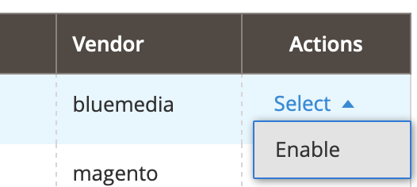
5. Click **Start Readiness Check**. It will start dependency verification. Then click **Next**.
6. (Optional) Create backup by checking all options and click **Create Backup**.   
   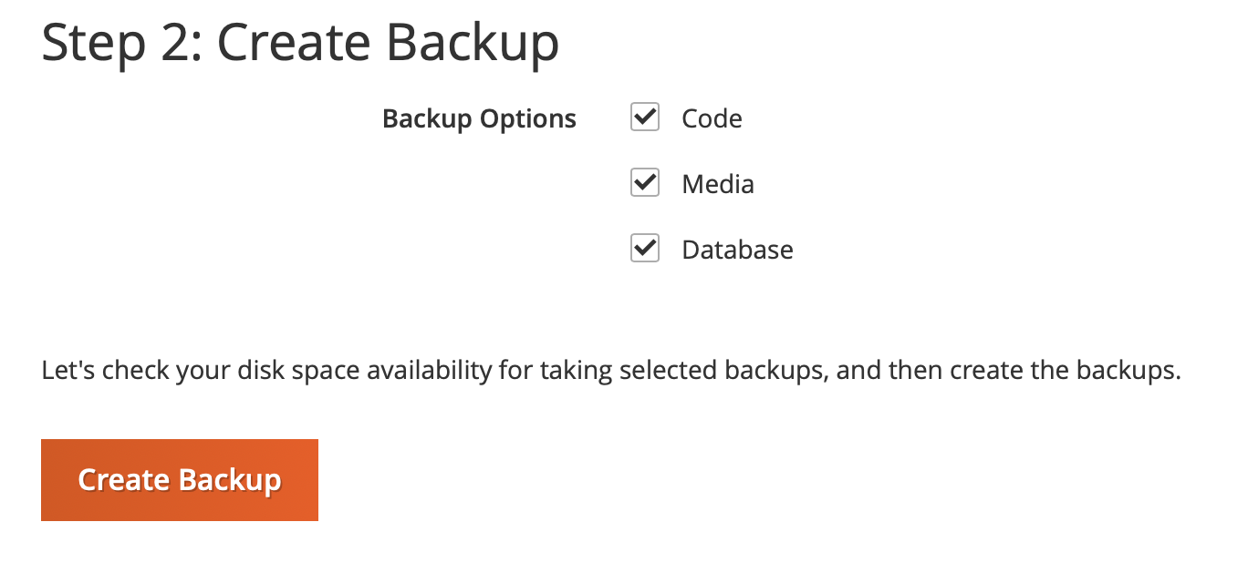
7. After creating backup or unchecking options, go further by clicking **Next**.
8. Click **Enable**. The store will be shut down during activation of the module.  
   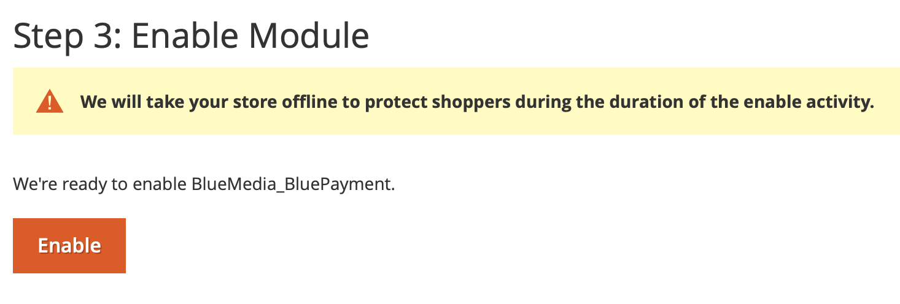
9. Module activation may take a while. After correct activation, the message will show up.  
   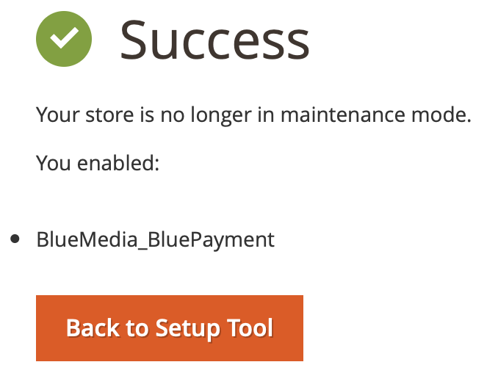

## Activation via command line

1. In Magento’s main catalog execute command:

* **bin/magento module:enable BlueMedia_BluePayment --clear-static-content**
* **bin/magento setup:upgrade**
* **bin/magento setup:di:compile**
* **bin/magento cache:flush**

1. The module is activated. You can go to Configuration.

# Configuration

It is available after logging into administration panel. Choose **Stores** -> **Configuration** in the menu, in next menu choose **Sales** -> **Payment Methods**, then expand on **OTHER PAYMENT METHODS** and **Online Payment BM**.

## Basic module configuration

1. Go to page module configuration.
2. Fill required fillings:
   1. **Enabled** on **Yes**.
   2. **Title** – the payment method title, which will be seen for customers.  
      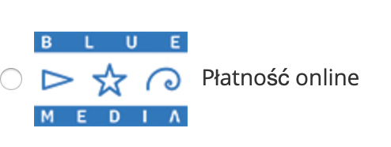
   3. **Test Mode**
3. Fill the data from BM in tab below for currency support:
   1. **ID service.**
   2. **Shared Key** - of the service provided to partner by BM.
4. Refresh cache.

## Payment gateways

Payment gateways are available after logging into administration. Choose **BluePayment** -> **Gateways** from menu on the left.

### Refreshing list of payment gateways

1. Go to List of payment gateways.
2. Click **Synchronize Gateways** on the right of the screen.

### Payment gateways editing

1. Go to List of payment gateways.
2. On the list click the row with payment gateway which you want to edit.
3. Available options:
   1. **Status** – it defines if gateway is currently available. Gateway refreshing proceed every 5 minutes (if CRON is configure correctly).
   2. (informational) **Currency**
   3. (informational) **ID**
   4. (informational) **Bank Name**
   5. (informational) **Name** – name of payment gateway.
   6. **Description** – Description which will be shown under gateway name.  
      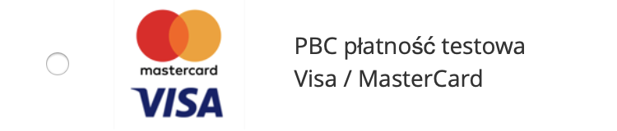
   7. **Sort Order** – sort order on the list of payment gateways, which:  
      1 – the first spot on the list,  
      2 – the second spot on the list,  
      ...  
      0 – the last spot on the list.
   8. (informational) **Type**.
   9. **Is separated method** – it causes showing up the payment gateways as separated payment method.  
      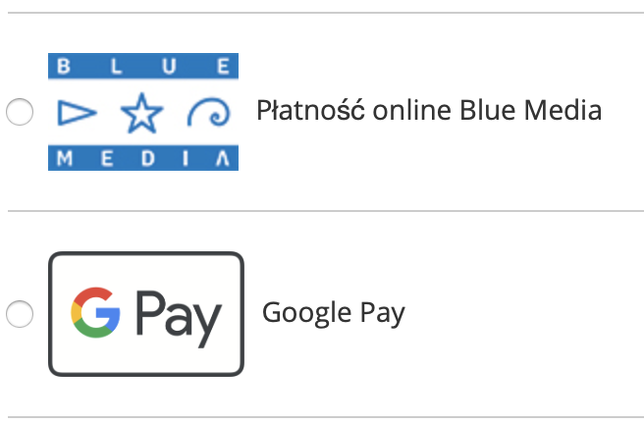
   10. (informational) **Logo URL**.
   11. **Use Own Logo** – it enables using your own logo for payment gateway.
   12. **Logo Path** – path to your own logo. It will be visible after checking **Use Own Logo** option.
   13. (informational) **Status Date** – date and time of the last gateway data update.
   14. **Force Disable** – it enables disabling payment gateway, regardless of **Status**.

## Collapsible gateway list

Available from 2.9.0 version. **Default enabled.**

In order to showing **always** full list:

1. Go to module configuration.
2. Set **Collapsible gateway list** to **Disabled**.
3. Refresh cache.

## Refreshing cache

Cache should be refreshed after every configuration editing.

1. Go to **System** -> **Cache Management**.
2. Check **Configuration**.
3. Choose **Refresh** from drop-down menu.
4. Click **Submit**.  
   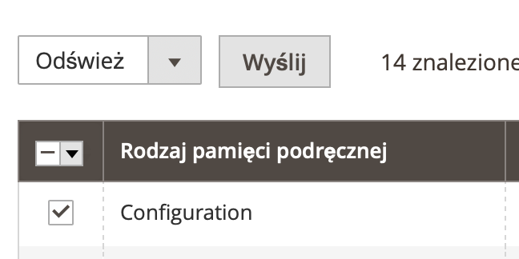

# Refunds

It allows to refund directly to client’s bank account from which the payment was done.

## Refund – Credit Memo

1. Go to **Invoice** details for order.
2. On the top menu bar, press **Credit Memo**.
3. Fill out the form with numer of items to refund, amount of fees.
4. Press **Refund**.

## Refund - manual

1. Go to order details.
2. If the order was paid via BM payment method, there will be **Refund BM** button on the top menu bar.  
   Obraz zawierający zrzut ekranu

   Opis wygenerowany automatycznie
3. The pop-up will appear with access to make full refund or partial refund.
   1. In case of partial refund type refund amount in format „000.00” (**dot as decimal separator**).
4. Confirm action with **OK** button.
5. Notification with refund confirmation or reason why refund isn’t possible will appear.
6. Information about refund will be accessible in:
   1. order comments,  
      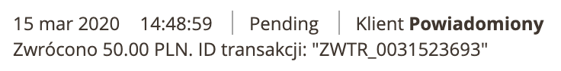
   2. transaction list.

# Payment in iframe

It enables paying via payment card without going out from the store and leaving purchase process. Implementation of this payment form requires two extra documents due to safety requirements of transaction process.

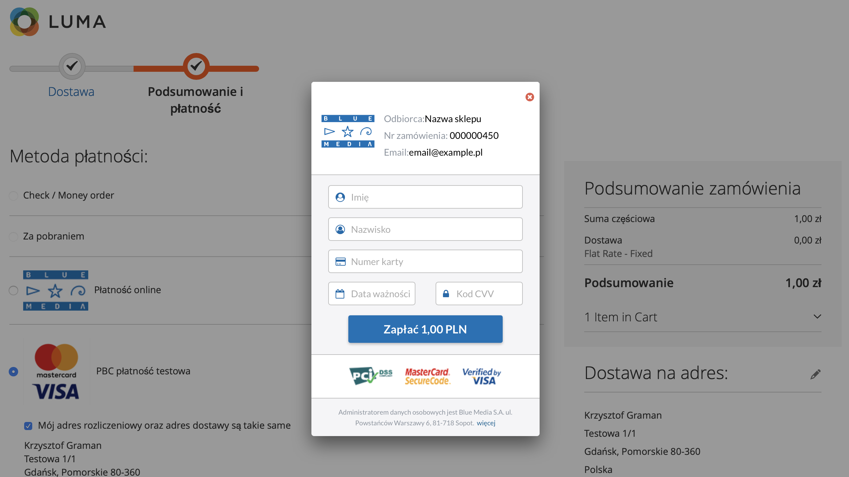

## Activation

1. Go to module configuration.
2. Set **Iframe Payment** option on **Enable.**
3. Go to gateway editing of ID **1500** and bank name **Cards**.
4. Set **Is separated method** option.
5. Refresh cache.

# BLIK 0

BLIK „inside the store”. In this case secure code is placing directly on the store’s webpage, on the last stage of purchase process.

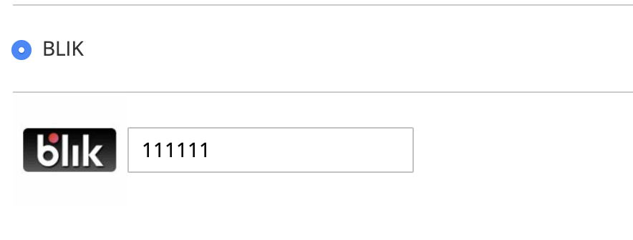

## Activation

1. Go to gateway editing of ID **509** and name **BLIK**.
2. Set **Is separated method** option.
3. Refresh cache.

# Google Pay

It enables payments using Google Pay. It is directly on the store’s webpage, on the last stage of purchase process. Due to activation this payment method, contact to your adviser.  
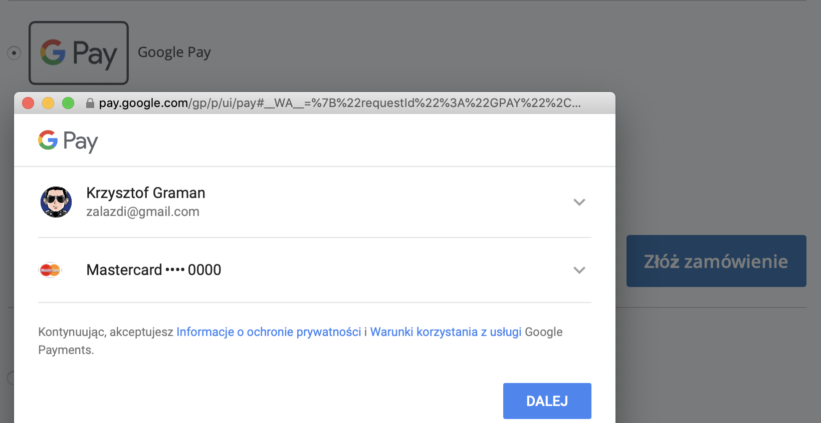

## Activation

Google Pay is activated by default.

Google Pay is always displayed as separated payment method.

# Automatic payments

One Click Payment is another way for comfortable payment via payment card. It enables quick payments with no need handing over all card’s probate data for customer every time. The payment process consists one-time card payment’s authorization and assigning card’s data to specific customer. The first transaction is secured by 3D-Secure protocol and next transactions are fulfilling by sending from partner clamour of card charging.

The automatic payment is available only for logged in customers.  
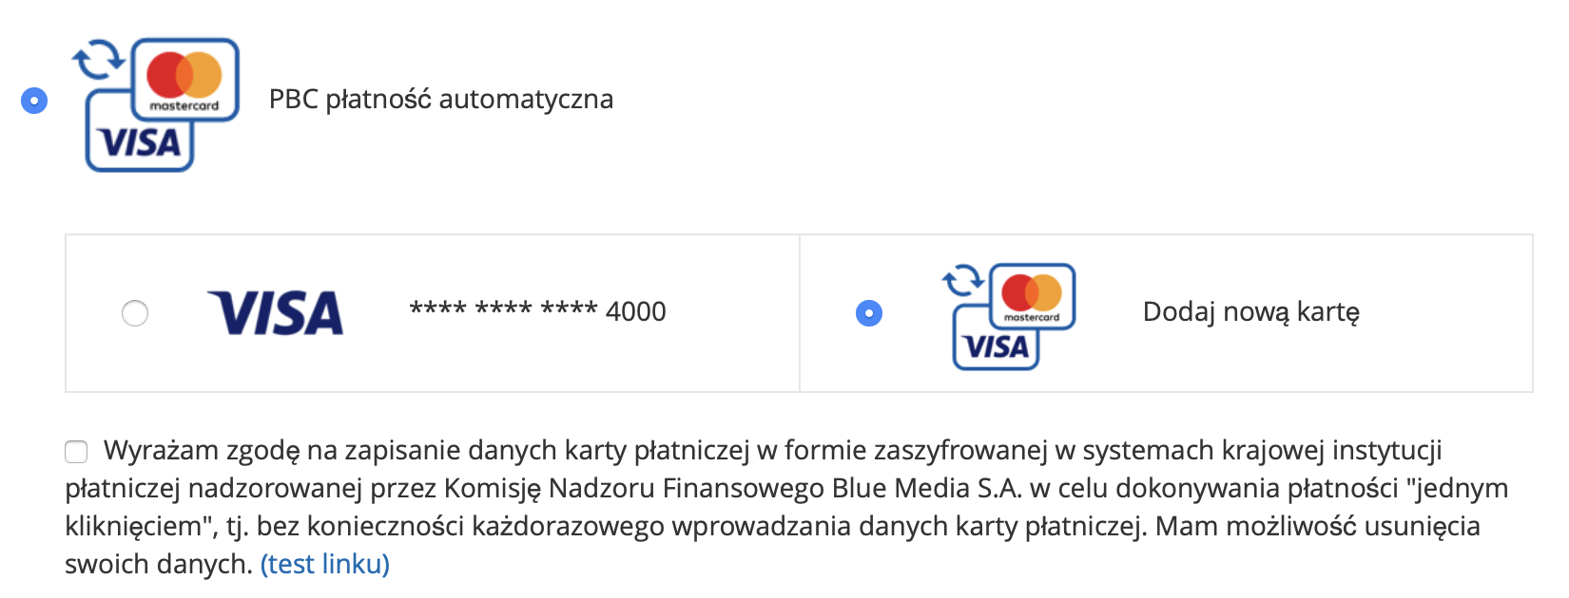

## Activation

1. Go to module configuration.
2. Fill **Autopay Agreement** appropriate terms of use to be accepted by customer.
3. Go to gateway editing of ID **1503** and type **Automatic Payment**.
4. Set **Is separated method** option.
5. Refresh cache.

## Card managing

The card stays saved and assigned to customer account during the first payment via automatic payment and accepting terms of use.

The customer is able to delate saved card in his account. To do this:

1. Log into the store.
2. Choose **My account** from upper menu.
3. Choose **Saved payment cards** from user menu on the left.
4. There will be list of saved cards:  
   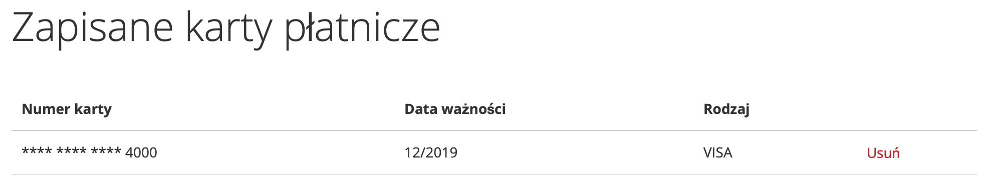
5. Click **Delate** and confirm.

# Generate orders from admin panel

Module allows send payment link to client for orders generated in admin panel.

For this, select **BM** payment method during generating order.

Payment link will be send by BM to e-mail address provided with customer data.

# E-mail template

For messages:

* email_creditmemo_set_template_vars_before
* email_invoice_set_template_vars_before
* email_order_set_template_vars_before
* email_shipment_set_template_vars_before

module appends available variables list with **payment_channel**. Example using in template:

**{{var payment_channel|raw}}**

# Waiting before redirect page

Module allows to add intermediate page, which is shown right before redirect to payment. It can be used to track e-commerce in Google Anaytics.

Template, which is used: **view/frontend/templates/redirect.phtml**

## Activation

1. Go to module configuration.
2. Set **Show waiting page before redirect** option to **Enable**.
3. Set **Seconds to wait before redirect** – to set how many second user will be waiting for redirect.
4. Refresh cache.

# Module updating

1. Download the latest version of the module from webpage <http://s.bm.pl/wtyczki>.
2. Upload .zip file to Magento’s main catalog.
3. In Magento’s main catalog execute commands:

* **unzip -o -d app/code/BlueMedia/BluePayment bm-bluepayment-*.zip && rm bm-bluepayment-*.zip**
* **bin/magento setup:upgrade**
* **bin/magento setup:di:compile**
* **bin/magento cache:flush**

1. The module has been updated.

# Module uninstallation

## Through Web Setup Wizard

1. Log into Magento’s administration panel.
2. Choose **System** -> **Web Setup Wizard** from main menu. System will ask you once again for logging in.
3. Go to **Component Manager**, find module **BlueMedia/BluePayment** on the list, click **Select** and then **Disable**.

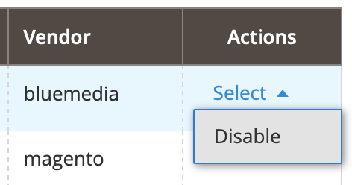

1. Click **Start Readiness Check**. It will start dependency verification. Then click Next.
2. (optional) Create backup by checking all options and clicking **Create Backup**.   
   
3. After creating backup or unchecking options, go further by clicking **Next**.
4. Click **Disable**. The store will be shut down during activation of the module. 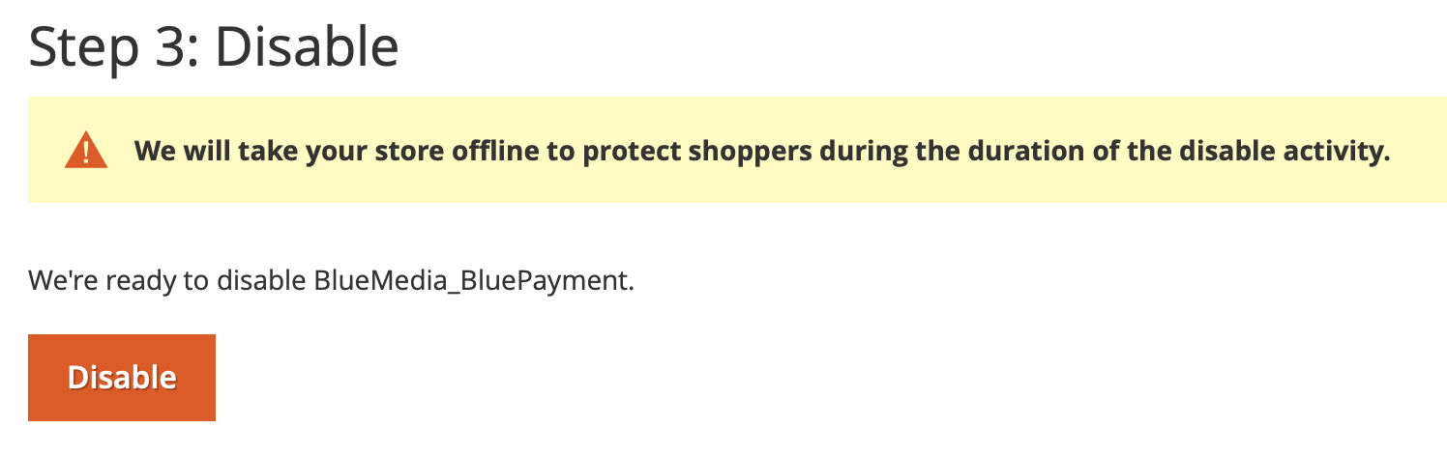
5. Deactivation of the module may take a few minutes. After correct deactivation, the message will show up.  
   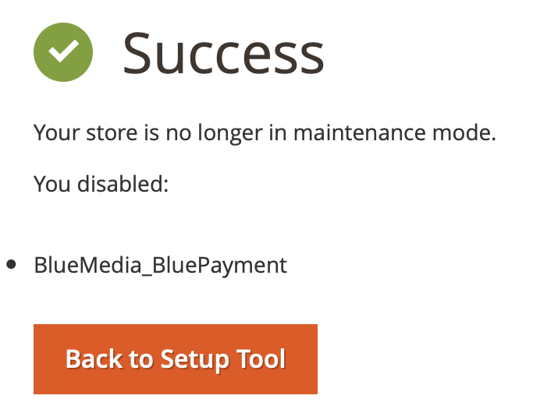

## Through command line

1. In Magento’s main catalog, execute commands:

* **bin/magento module:disable BlueMedia_BluePayment --clear-static-content**
* **bin/magento setup:upgrade**
* **bin/magento setup:di:compile**
* **bin/magento cache:flush**

## (optional) Cleaning files and data bases

1. In Magento’s main catalog delate catalog:  
   **app/code/BlueMedia**
2. Execute following queries to data base:

* **DROP TABLE `blue_card`;**
* **DROP TABLE `blue_gateway`;**
* **DROP TABLE `blue_refund`;**
* **DROP TABLE `blue_transaction`;**

1. Due to delating whole module configuration, execute following query to data base:

* **DELETE FROM `core_config_data` WHERE `path` LIKE 'payment/bluepayment%';**